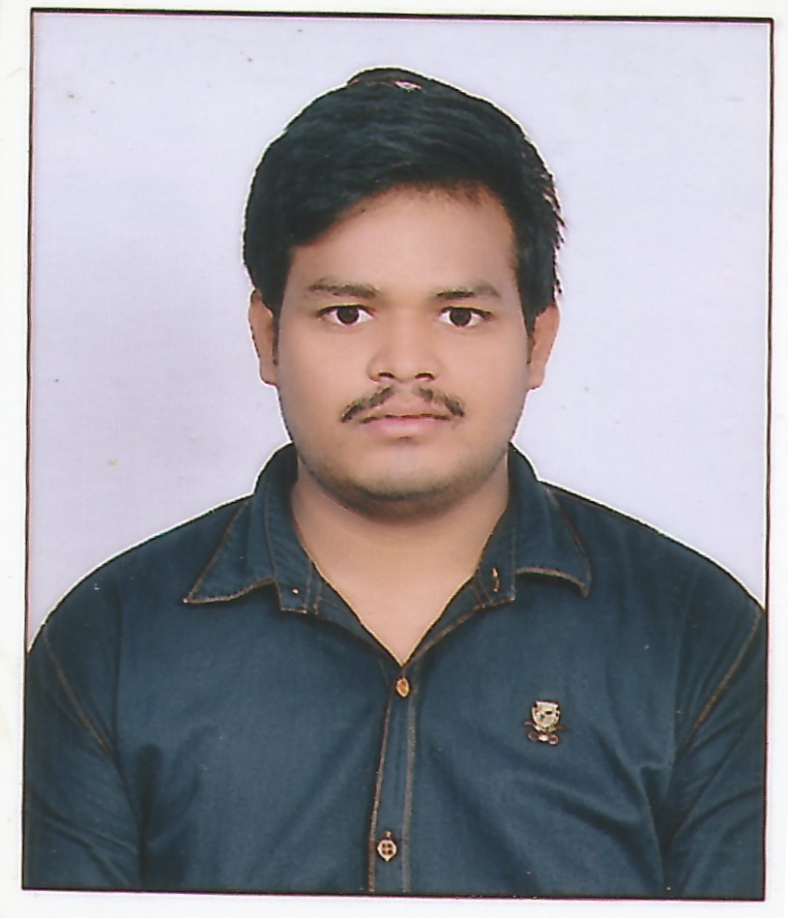
RESUME

SUNIL KUMAR MAURYA
Email: Sunilmaurya278@gmail.com
Mobile: 9170434170

Objective

I want to work in a challenging environment for growth and realization of complete self potential and to provide better services to organization.

Educational Qualification

 |  | Academic/Degree |  | Institute Name |  | University/Board | Percentage |  |  |  | Year
 |  | MCA |  | M.J.P. Rohilkhand University, Bareilly, Uttar Pradesh |  | MJPRU, Bareilly | 7.81 DGPA |  |  | 2020
 |  | B.Sc(IT) |  | Maharishi University of Information Technology, Lucknow |  | MUIT, Lucknow | 68.8 % |  |  | 2017
 |  | Intermediate |  | Maharana Pratap Inter College, Gorakhpur |  | UP BOARD | 53.8 % |  |  | 2014
 |  | High School |  | Kendriya Vidyalaya No.2, Gorakhpur |  | CBSE BOARD | 6.2 CGPA |  |  | 2012

Technical Skills

 | Language Known | HTML, CSS, Bootstrap, Python, Django, PHP, Laravel, MySQL
 | Software Knowledge | Pycharm, Anaconda, VS code

Academic Projects Undertaken

Digital Learning Hub(https://iqburn.herokuapp.com/)
Sep 2019 - Oct 2019
In this project we can create e-Learning site. Here we can provide online study meterials etc.

Certification & Achievements

- TCS NQT (2021) score card- 1043.12 marks out of 1800
- Python & Django course from NARESH i Technologies, Hyderabad
(Jan 2020-May 2020)

Working Experience

- Fresher

Personal Details

 | Father’s Name | RAM PRATP MAURYA
 | Nationality | Indian
 | Marital status | Single
 | Date of Birth | 10/06/1996
 | Address | Vill-Manbela Maurya Tola,Po- Jhungiya Bazar, Gorakhpur(UP), 273013

Declaration

I hereby declare that the above mentioned information is correct up to my knowledge and I bear the responsibility for the correctness of the above mentioned particulars.

Place: Noida SUNIL KUMAR MAURYA

Date: 20/05/2021

